Update Job information.

1. Click Modify Previous

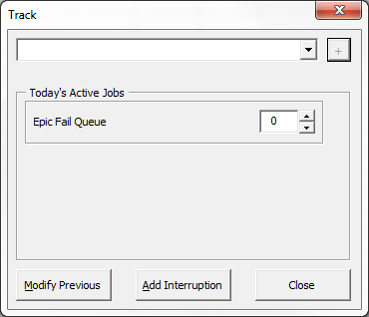

1. Select the Job function you want to modify and click modify.

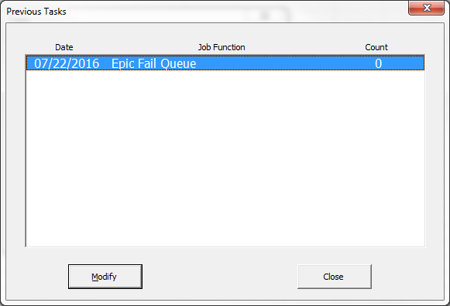

1. Select the Element you want to modify.

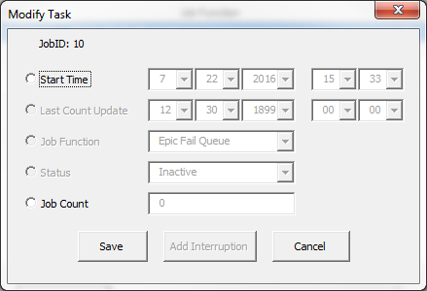

1. Modify the element and click save.